CS 504 Software Engineering

**HOS08A –** **CI/CD**

05/12/2023 Developed by Ajay Naik

05/12/2023 Reviewed by Marcelo Guerra Hahn

09/22/2024 Reviewed by Yogesh Goel

11/07/2024 Reviewed by Naveena Moddu

School of Technology & Computing (STC) @ City University of Seattle (CityU)



**Before You Start**

* Version numbers may not match the most current version at the time of writing. If given the option to choose between the stable release (long-term support) or the most recent, please select the stable release rather than the beta-testing version.
* This tutorial targets Windows users and MacOS users.

**Instructions**

1. Create a Word Document.
2. Include a snapshot of each step in the document.

**Learning Outcomes**

* Deploy Static Website on Azure
* CI/CD pipeline

**Resources**

* Loubser, N. (n.d.-b). Software Engineering for Absolute Beginners: Your Guide to Creating Software Products. O'Reilly Online Learning. <https://learning.oreilly.com/library/view/software-engineering-for/9781484266229/>
* https://learn.microsoft.com/en-us/azure/static-web-apps/

**Introduction**

In this HOS, we will learn about creating a static website on the Azure platform with a CI/CD pipeline.

**Creation of a Static Website**

Login to the git hub account and click on New to create repository.

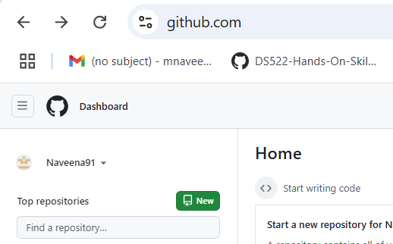

Enter the details as shown in the following picture and create the repository.

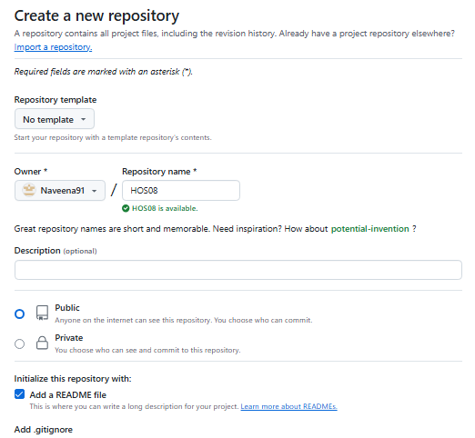

Clone the repository and add an index.html file with the following tag.

<h1>Hello<h1>

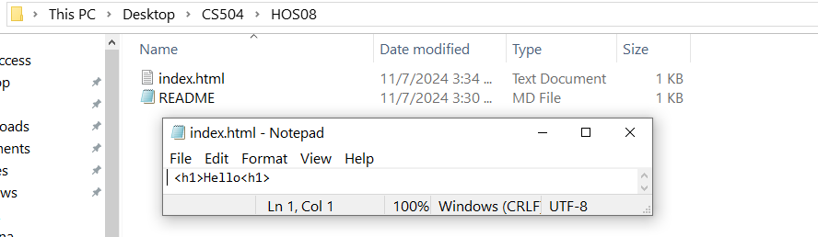

Push index.html to GitHub.

**Azure Sign-In**

Click on [Azure](https://azure.microsoft.com/en-us/get-started/azure-portal), and click on Free Account (top right-side corner).

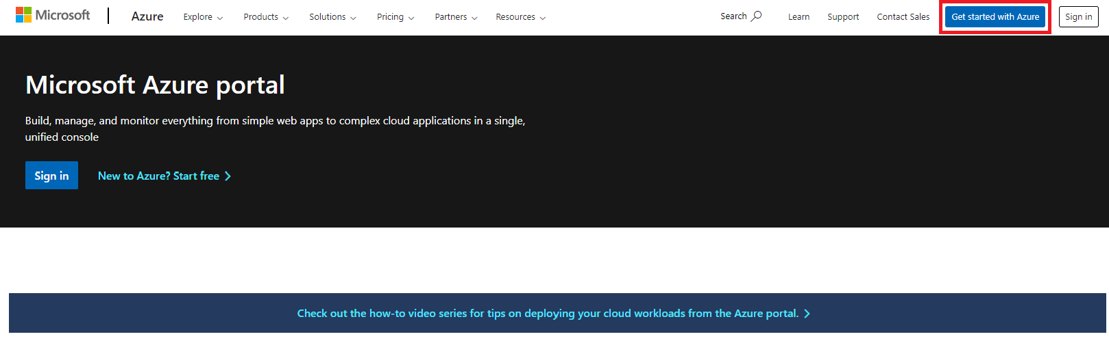

Click on Start Free and Sign In with your Microsoft Account. Follow the Sign-up process.

For more information on the Sign-In process, follow <https://learn.microsoft.com/en-us/training/modules/create-an-azure-account/>

Once the sign-up process is complete, you should see the following page.

Click On "Go to the Azure portal" and sign in with your Microsoft account.

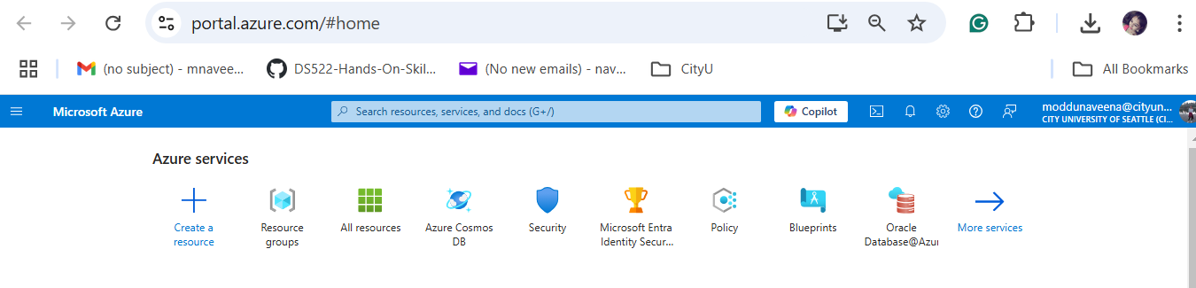

In the Search bar, enter "Static." Click on static Web Apps

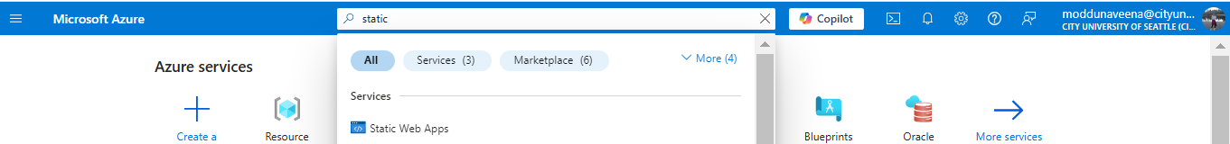

Select either “Start with an Azure free trial” or “Access student benefits” for a free trial version

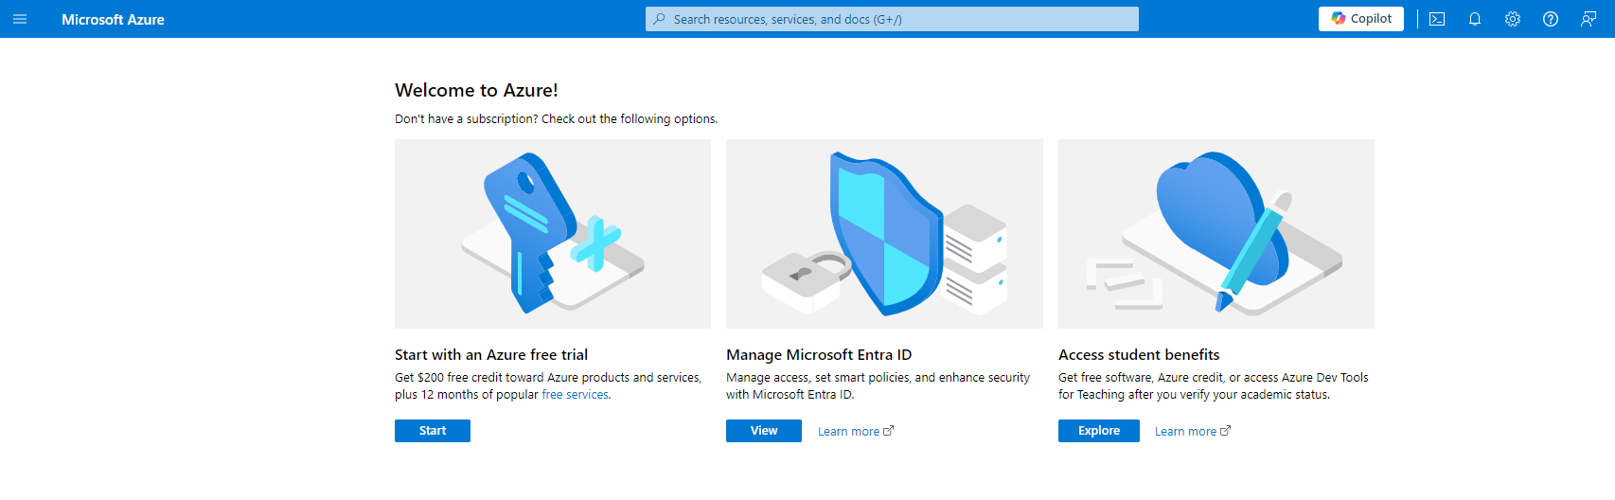

Select Static Web Apps.

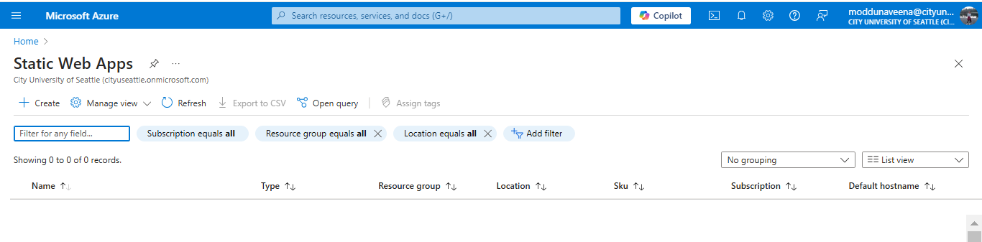

Click Create, and Enter the details as highlighted in the following picture.

Name: HOS08

Plan type: Free: For hobby or personal projects

Region for Azure Functions API and staging environments: West US 2

**Important:** Select **Free: For hobby or personal projects** as the Plan Type; otherwise, you will get charged.

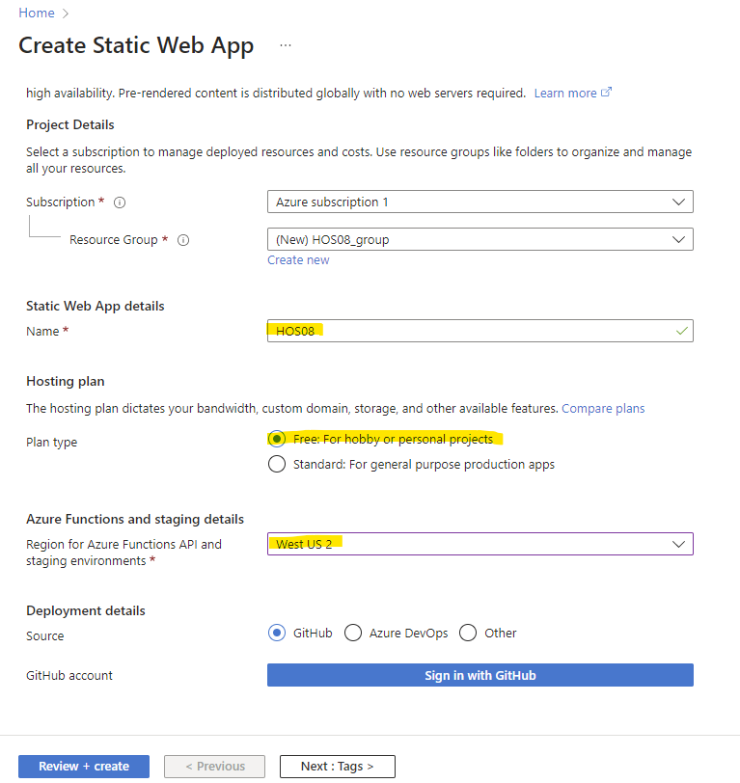

Click on Sign in with GitHub.

Click on Authorize Azure-App-Service-Static-Web-Apps.

Fill in the details as highlighted in the following picture.

Organization: Select GitHub Account

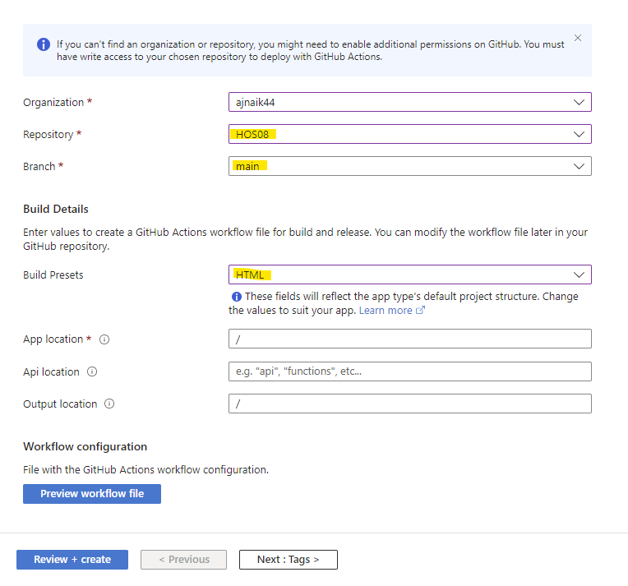

Click on the Review + create button.

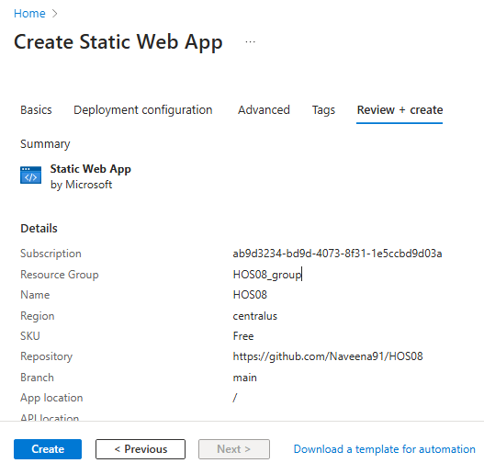

Click on Create.

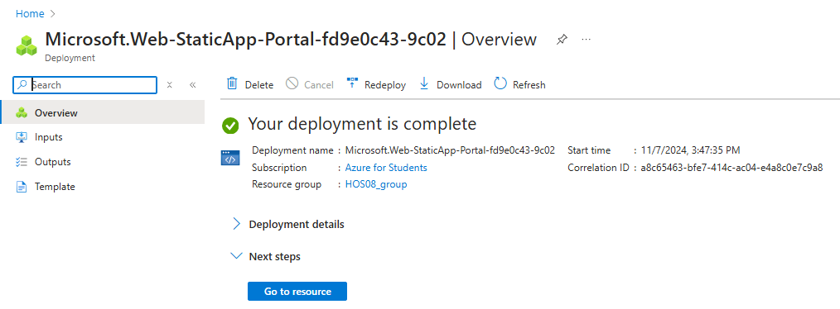

Click on "Go to resource".

Copy the URL and open it in a new tab.

Open your HOS08 (git branch created as part of step “Creation of a Static Website”).

In Visual Studio Code, open a new terminal, and type the following command.

git checkout -b development

The following should appear.

Modify the index.html file with the following code.

<h1>Hello World!<h1>

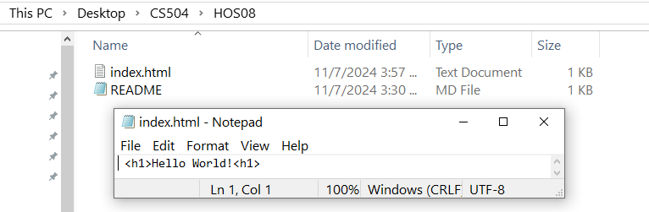

Enter the following command in the Terminal

git add –all

git commit -m "development branch"

git push -f origin development

The following should appear.

Go to git hub account and click on Pull request.

Click on Compare & pull request à Create pull request à Merge pull request à Confirm the merge.

**Note**: Detailed steps about the merging process are explained in HOS02.

Click on Actions and wait till all the jobs are completed.

Go to Azure Portal à Static Web Apps à Select HOS08

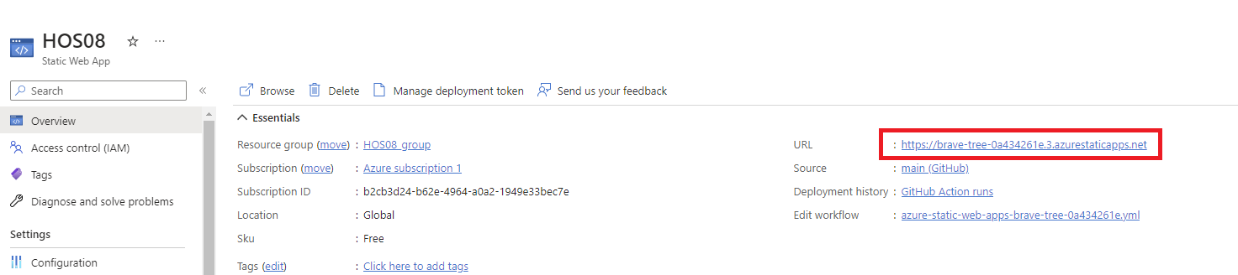

Copy the URL and open it in the new

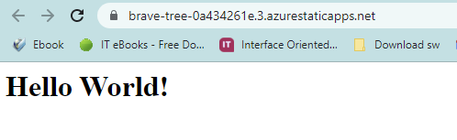

Once the Web App is running, we will delete the resource which we have created.

Go to Azure Portal à Static Web Apps à Select HOS08

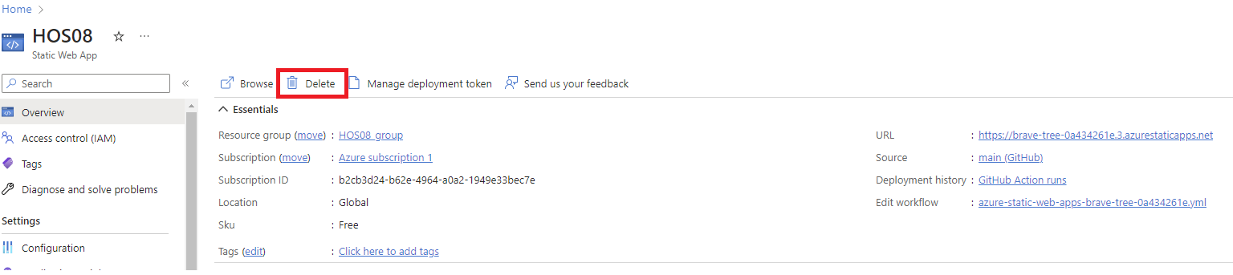

Click on Delete

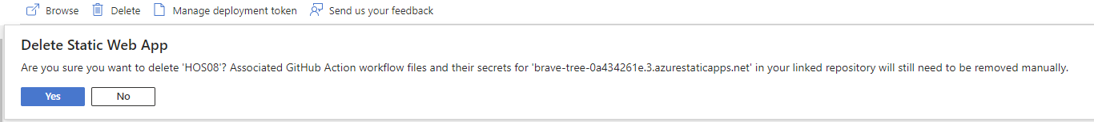

Click on Yes and wait for the process to complete.

**Push your work to GitHub**

Open the Terminal from the VS Code by hitting the control + ~ key and typing the following command:

Run the following commands to push your work to the GitHub repository:

git add --all

git commit -m "Submission for Module 8"

git push